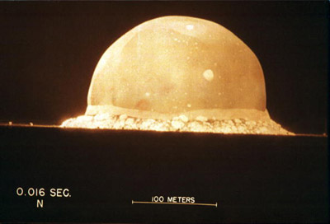
On Aug. 6, 1945, Paul Tibbets, pilot of the B-29 airplane named the Enola Gay, dropped an atomic bomb over the Japanese city of Hiroshima. Nicknamed "Little Boy," the bomb created an explosion equivalent to 15,000 tons of TNT, destroying nearly every building within a mile of ground zero and creating a massive firestorm that eventually engulfed the city. It's believed that 70,000 citizens died immediately after the blast, but the eventual death total may have reached as many as 100,000 by the end of the 1945 and 200,000 after 5 years due to the effects of radiation [source: U.S Department of Energy]. Three days later on Aug. 9 a second bomb was dropped on the industrial city of Nagasaki. Nicknamed "Fat Man," the second bomb killed about 40,000 people initially, and the death toll eventually reached 70,000 after the end of the year and 140,000 after 5 years [source: U.S. Department of Energy]. Japan surrendered to the Allied forces on Aug. 14, 1945, officially ending World War II.
The development and use of the atomic bomb, the most powerful weapon created by the human race, is viewed as one of the most important and controversial events in the 20th century. Its terrifying ability to devastate an entire city and its symbol as a source of power sparked a tense nuclear arms race between the United States and the Soviet Union after the end of the war. Modern warfare had changed dramatically at the beginning of the century -- airplanes, machine guns and biological and chemical warfare were just a few of the technological advancements that caused widespread devastation and altered military tactics. But the atomic bomb was a different story. Some people thought its existence would put an end to all war, while others feared the potential annihilation of the human race.
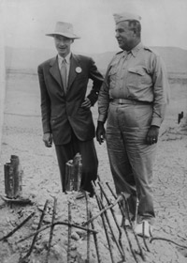
The Manhattan Project, the code name for the United States' secret plan to develop atomic weapons for use in warfare, was a broad designation for the people, geographic locations and resources involved in atomic research during World War II. Many were, and still are, split on the decision to use the bomb in Japan, including the very people who helped build it. Some feel it saved lives and ended World War II, while others argue the Japanese would have surrendered anyway.
How did they do it? Who was involved? Why did they call it the Manhattan Project anyway? We'll take a closer look at the Manhattan Project and how a large network of scientists and military personnel managed to create the most powerful display of energy the Earth has ever witnessed.
Nuclear physicist Robert Oppenheimer, left, with Major General Leslie Groves, by the remains of the tower from which an atom test bomb was ignited.

Manhattan Project Organization
By March 1942, the Army Corps of Engineers became directly involved with S-1 meetings, and on Sept. 18 Colonel Leslie R. Groves was appointed head of the project, now officially known as the Manhattan Project. With a strong background in engineering -- he oversaw with the construction of the Pentagon -- Groves turned out to be an incredibly skilled administrator and contributed greatly to the bomb's success within an impossibly short time span.
Over the next year Groves would select several sites across the United States that would aid in the bomb's completion, including Oak Ridge, Tenn. (Site X) and Hanford, Wash. (Site W). These locations were massive facilities meant for uranium and plutonium production. When Groves selected Robert Oppenheimer, professor of theoretical physics at Berkeley, to act as director of Project Y, the two chose Los Alamos, New Mexico, as the site that would be the central hub of the Manhattan Project.
Los Alamos, along with the sites in Tennessee and Washington State, were remote locations picked for maximum security, but you wouldn't know it if you saw pictures of them during peak production. The desolate New Mexican mesa in Los Alamos, for instance, was essentially turned into a small city, with laboratories, offices, dining halls and housing for everyone involved in the project. Oppenheimer worked hard on gathering the best scientific minds in the country, and for nearly three years between the fall of 1942 and the bombing of Hiroshima on Aug. 6, 1945, thousands of people worked through the challenges of constructing an atomic weapon.
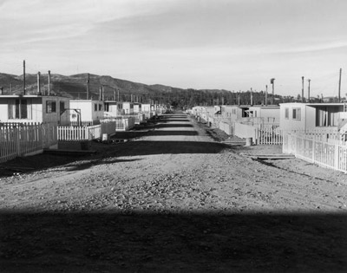
Simple housing for the workers involved in the Manhattan Project at Los Alamos, N.M.
Security at Los Alamos was extremely tight, as people were hardly allowed to contact family members and friends for their entire stay at Site Y. Guards were tough on clearance issues, and barbed wire surrounding the entire complex. The Manhattan Project was enveloped in so much secrecy, in fact, that some people didn't even know the nature of their work until they heard news of the bomb exploding over Hiroshima.
Two types of nuclear bombs were designed at Los Alamos -- an implosion bomb and a gun-triggered bomb. After major improvements were made on the implosion device, a site was finally chosen to test the first nuclear bomb. Alamogordo, a desert range about 210 miles south of Los Alamos, was nicknamed "Trinity" for the testing of a plutonium bomb design -- Oppenheimer allegedly recalled a John Donne poem that begins "Batter my heart three-person'd God" and felt the comparison fitting. At 5:30 a.m. on July 16, 1945, the bomb was detonated, creating a massive blast and temporarily blinding several of the observing scientists: the Atomic Age had begun.
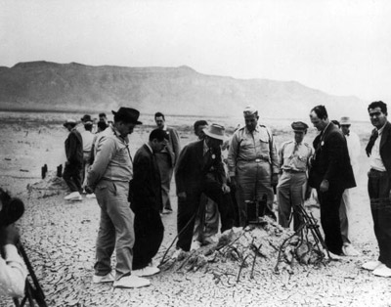
Manhattan Project officials, including Dr. Robert J. Oppenheimer (white hat) and General Leslie Groves, inspect the detonation site of the Trinity atomic bomb test.
Los Alamos National
Less than a month later, the United States used the implosion bomb and the untested gun-triggered bomb in order to coerce the Japanese into surrender. Although the bomb arguably ended the conflict overseas by ending ground combat in Japan, the bomb's existence ushered in a nuclear arms race that would dramatically alter the second half of the 20th century.
If you'd like to learn more about the Manhattan Project and nuclear weapons, follow the links on the next page.

Questions to Consider: Please write out these questions on a separate sheet of paper. You may use one sheet for the entire group, but make sure that all of your names are on it.
- Why do you think some of the people participated in the Manhattan Project without fully knowing what they were helping to create?
- Do you think that dropping the atomic bomb was necessary?
- If the United States has nuclear weapons capabilities, should other countries be able to develop that capability? Why or why not?

As a group, be able to summarize this article for the rest of the class. If you would like to write a few bullet point notes to help you, feel free.

