America’s Founding Exam Review

Define the term ratification

Who is the primary author of the Declaration of Independence?

Who is considered the father of the Constitution

What is the Virginia Plan?

What is the New Jersey Plan?

What is the Great Compromise?

What is the 3/5 Compromise?

What did anti-federalists want added to the constitution in order to ratify it?

What is the enlightenment?

What is the Great Awakening?

Where was the constitutional convention held?
What does the preamble to the Constitution say?

What are the three branches of government?

What five items did the Townshend Acts tax?

What happened at the Second Continental Congress? (2 things)

What is federalism?

Who wrote the pamphlet called Common Sense?

Why were the Articles of Confederation considered a weak government?

What is the Quartering Act?

What are checks and balances?

What is the Boston Massacre?

How did it start?
How many people died?

Who has the power to declare war?

Congress is set up as a ___________________legislature. One is the _____________ of Representatives,
the other is the ________________.

What role does the Vice President play in Congress?

What is the Land Ordinance of 1785?

What is the Proclamation of 1763?

How many justices are on the Supreme Court?

Define the following amendments:
1

2

3

4

5

6

7

8

9
10

13

14

15

Describe some of the events that caused American Revolution. You will need to accurately describe at least three events for full credit.

What were some of the problems faced by the framers of the constitution? How did they solve them? You will have to discuss three problems and solutions for full credit.

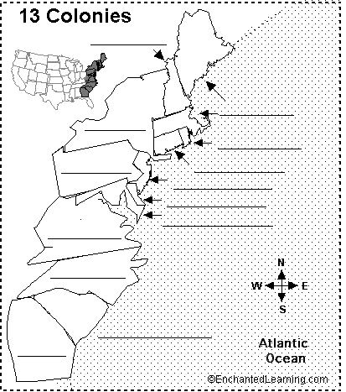
Identify the 13 colonies.

