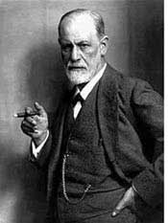
Sigmund Freud by Saul McLeod
Sigmund Freud explored the human mind more thoroughly than any other who became before him.
His contributions to psychology are vast. Freud was one of the most influential people of the twentieth century and his enduring legacy has influenced not only psychology, but art, literature and even the way people bring up their children.
Freud’s lexicon has become embedded within the vocabulary of western society. Words he introduced through his theories are now used by everyday people, such as anal (personality), libido, denial, repression, cathartic, Freudian slip, and neurotic.
Freud was the founding father of psychoanalysis, a method for treating a mental illness and also a theory which explains human behavior.
Psychoanalysis is often known as the talking cure. Typically Freud would encourage his patient to talk freely (on his famous couch) regarding their symptoms and to describe exactly what was in their mind.

The Case of Anna O
The case of Anna O (real name Bertha Pappenheim) marked a turning point in the career of a young Viennese neuro-pathologist by the name of Sigmund Freud. It even went on to influence the future direction of psychology as a whole.
Anna suffered from hysteria, a condition in which the patient exhibits physical symptoms (e.g. paralysis, convulsions, hallucinations, loss of speech) without apparent physical cause. Her doctor Josef Breuer succeeded in treating Anna by helping her to recall forgotten memories of traumatic events. Breuer discussed the case with his friend Freud. Out of these discussions came the germ of an idea that Freud was to pursue for the rest of his life.
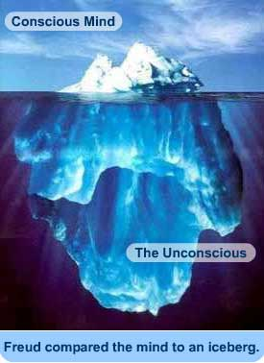
In “Studies in Hysteria” (1895) Freud proposed that physical symptoms are often the surface manifestations of deeply repressed conflicts. However Freud was not just advancing an explanation of a particular illness. Implicitly he was proposing a revolutionary new theory of the human psyche itself.
This theory emerged “bit by bit” as a result of Freud’s clinical investigations and it led him to propose that there were at least three levels to the mind.

The Unconscious Mind
Freud (1900, 1905) developed a topographical model of the mind, whereby he described the features of mind’s structure and function.
In this model the conscious mind (everything we are aware of) is seen as the tip of the iceberg, with the unconscious mind a repository of a ‘cauldron’ of primitive wishes and impulse kept at bay and mediated by the preconscious area.
However, Freud found that some events and desires were often too frightening or painful for his patients to acknowledge. Freud believed such information was locked away in a region he called the unconscious mind. This happens through the process of repression.
Sigmund Freud emphasized the importance of the unconscious mind, and a primary assumption of Freudian theory is that the unconscious mind governs behavior to a greater degree than people suspect. Indeed, the goal of psychoanalysis is to make the unconscious conscious.

The Psyche
Freud (1923) later developed a more structural model of the mind comprising the entities id, ego and superego (what Freud called “the psychic apparatus”). These are not physical areas within the brain, but rather hypothetical conceptualizations of important mental functions.
Freud assumed the id operated at an unconscious level according to the pleasure principle. The id is contains two kinds of biological instincts (or dives) which Freud called Eros and Thanatos.
Eros, or life instinct, helps the individual to survive; it directs life-sustaining activities such as respiration, eating and sex (Freud, 1925). The energy created by the life instincts is known as libido.
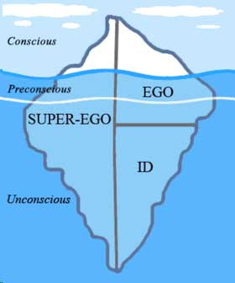
In contrast, Thanatos or death instinct, is viewed as a set of destructive forces present in all human beings (Freud, 1920). When this energy is directed outward onto others, it is expressed as aggression and violence. Freud believed that Eros or stronger than Thanatos, thus enabling people to survive rather than self-destruct.
The ego develops from the id during infancy. The egos goal is to satisfy the demands of the id in a safe a socially acceptable way. In contrast to the id the ego follows the reality principle as it operates in both the conscious and unconscious mind.
The superego develops during early childhood (when the child identifies with the same sex parent) and is responsible for ensuring moral standards are followed. The Superego operates on the morality principle and motivates us to behave in a socially responsible and acceptable manner.
The superego can make a person feel guilty if rules are not followed. When there is conflict between the goals of the id and superego the ego must act as a referee and mediate this conflict. The ego can deploy various defense mechanisms (Freud, 1894, 1896) to prevent it from becoming overwhelmed by anxiety.

Defense Mechanisms
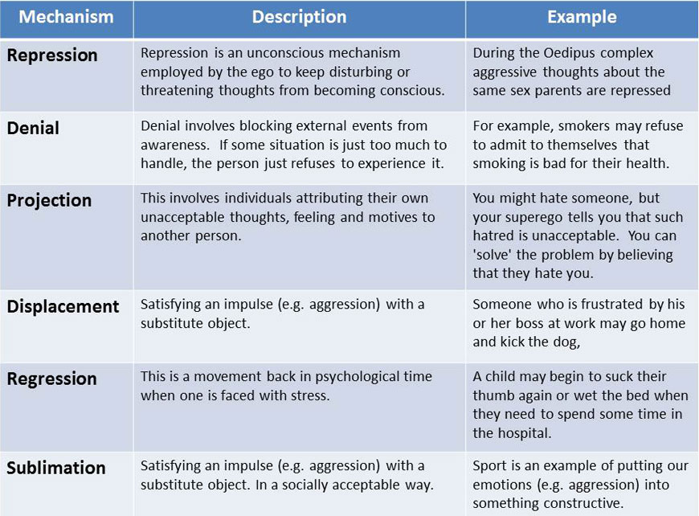

Psychosexual Stages
In the highly repressive “Victorian” society in which Freud lived and worked women, in particular, were forced to repress their sexual needs. In many cases the result was some form of neurotic illness.
Freud sought to understand the nature and variety of these illnesses by retracing the sexual history of his patients. This was not primarily an investigation of sexual experiences as such. Far more important were the patient’s wishes and desires, their experience of love, hate, shame, guilt and fear – and how they handled these powerful emotions.
It was this that led to the most controversial part of Freud’s work – his theory of psychosexual development and of the Oedipus complex
Freud believed that children are born with a libido – a sexual (pleasure) urge. There are a number of stages of childhood, during which the child seeks pleasure from a different ‘object’.

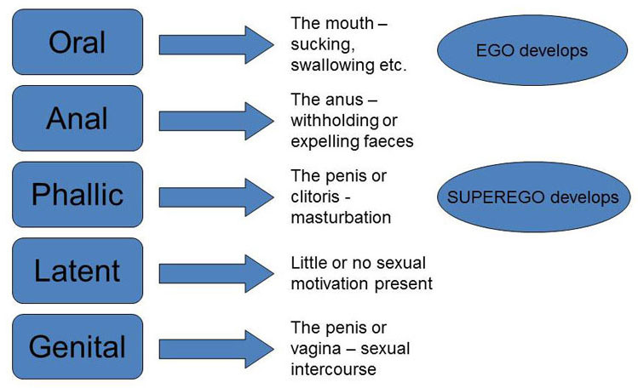
To be psychologically healthy, we must successfully complete each stage. Mental abnormality can occur if a stage is not completed successfully – the person becomes ‘fixated’ in a particular stage. This particular theory shows how adult personality is determined by their childhood experiences.

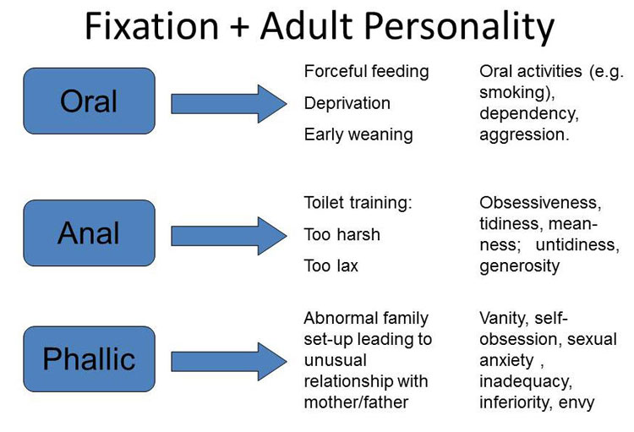

Dream Analysis
Freud (1900) considered dreams to be the 'royal road to the unconscious' as it is in dreams that the ego's defenses are lowered so that some of the repressed material comes through to awareness, albeit in distorted form.
Dreams both perform important functions for the unconscious mind and serve as valuable clues to how the unconscious mind operates.
On 24 July 1895, Freud had his own dream that was to form the basis of his theory. He had been worried about a patient, Irma, who was not doing as well in treatment as he had hoped. Freud in fact blamed himself for this, and was feeling guilty.
Freud dreamed that he met Irma at a party and examined her. He then saw a chemical formula for a drug that another doctor had given Irma flash before his eyes and realized that her condition was caused by a dirty syringe used by the other doctor. Freud's guilt was thus relieved.
Freud interpreted this dream as wish-fulfillment. He had wished that Irma's poor condition was not his fault and the dream had fulfilled this wish by informing him that another doctor was at fault. Based on this dream, Freud (1900) went on to propose that a major function of dreams was the fulfillment of wishes.
Freud distinguished between the manifest content of a dream (what the dreamer remembers) and the latent content, the symbolic meaning of the dream (i.e. the underlying wish). The manifest content is often based on the events of the day.
The process whereby the underlying wish is translated into the manifest content is called dream-work. The purpose of dream work is to transform the forbidden wish into a non-threatening form, thus reducing anxiety and allowing us to continuing sleeping. Dream work involves the process of displacement, condensation and secondary elaboration.
Dream analysis involves the translation of the (inevitably distorted) manifest content into the (truthful) latent meaning. Understanding the various distorting processes would help us to understand the latent meaning of a dream.
The process of condensation is the joining of two or more idea/images into one. For example, a dream about a man may be a dream about both one's father and one's lover. A dream about a house might be the condensation of worries about security as well as worries about one's appearance to the rest of the world.
Displacement takes place when we transform the person or object we are really concerned about to someone else. For example, one of Freud’s patients was extremely resentful of his sister-in-law and used to refer to her as a dog, dreamed of strangling a small white dog. Freud interpreted this as representing his wish to kill his sister-in-law. If the patient would have really dreamed of killing his sister-in-law, he would have felt guilty. The unconscious mind transformed her into a dog to protect him.
Secondary elaboration occurs when the unconscious mind strings together wish-fulfilling images in a logical order of events, further obscuring the latent content. According to Freud this is why the manifest content of dreams can be in the form of believable events.
In Freud’s later work on dreams he explored the possibility of universal symbols in dreams. Some of these were sexual in nature, including poles, guns and swords representing the penis and horse riding and dancing representing sexual intercourse.
However, Freud was cautious about symbols and stated that general symbols are personal rather than universal. A person cannot interpret what the manifest content of a dream symbolized without knowing about the person’s circumstances.
'Dream dictionaries', which are still popular now, were a source of irritation to Freud. In an amusing example of the limitations of universal symbols, one of Freud's patients, after dreaming about holding a wriggling fish, said to him 'that's a Freudian symbol - it must be a penis!'
Freud explored further and it turned out that the woman's mother, who was a passionate astrologer and a Pisces, was on the patient's mind because she disapproved of her daughter being in analysis. It seems more plausible, as Freud suggested, that the fish represented the patient's mother rather than a penis!

Freud's Followers
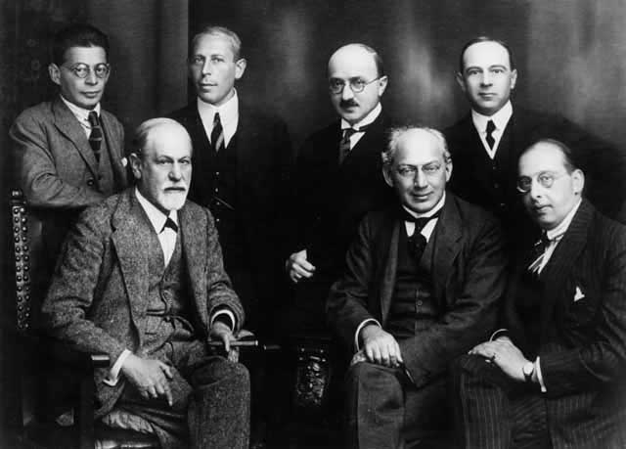
Freud attracted many followers, who formed a famous group in 1902 called the "Psychological Wednesday Society". The group met every Wednesday in Freud's waiting room.
As the organization grew, Freud established an inner circle of devoted followers, the so-called "Committee" (including Sàndor Ferenczi, and Hanns Sachs (standing) Otto Rank, Karl Abraham, Max Eitingon, and Ernest Jones).
At the beginning of 1908 the committee had 22 members and renamed themselves the Vienna Psychoanalytic Society.

Critical Evaluation
Freud's theory is good at explaining but not a predicting behavior (which is one of the goals of science). For this reasons Freud's theory is unfalsifiable - it can neither be proved true or refuted. For example, the unconscious mind is difficult to test and measure objectively. Overall, Freud's theory is highly unscientific.
Furthermore , most of the evidence for Freud's theories is taken from an unrepresentative sample. He mostly studied himself, his patients and only one child (e.g. Little Hans).
The main problem here is that the case studies are based on studying one person in detail, and with reference to Freud the individuals in question are most often middle aged women from Vienna (i.e. his patients).
This makes generalizations to the wider population (e.g. the whole world) difficult. However, Freud thought this unimportant, believing in only a qualitative difference between people.
Freud may also have shown research bias in his interpretations - he may have only paid attention to information which supported his theories, and ignored information and other explanations that did not fit them.
However, Fisher & Greenberg (1996) argue that Freud’s theory should be evaluated in terms of specific hypotheses rather than as a whole. They concluded that there is evidence to support Freud’s concepts of oral and anal personalities and some aspects of his ideas on depression and paranoia. They found little evidence for the Oedipal conflict and no support for Freud’s views on women’s sexuality and how their development differs from men’s.
Assignment: Write a 2-3 paragraph summary of this article.

